# CSP554—Big Data Technologies

## Assignment #5 (Modules 05)

## Generating Magic_Number:

## Magic Number - 52463

## 

## Exercise 1:

Command:

food_ratings = LOAD '/user/foodratings52463.txt' USING PigStorage(‘,’) AS (name:Chararray,f1:int,f2:int,f3:int,f4:int,placeid:int);



**Exercise 2)**

**Now create another relation with two fields of the initial (food_ratings) relation: ‘name’ and ‘f4’. Call this relation ‘food_ratings_subset’.**

**Store this last relation, food_ratings_subset, back to HDFS (perhaps as the file /user/hadoop/fr_subset)**

**Also write 6 records of this relation out to the console.**

**Submit the pig latin statements you used and the six records printed out to the console as the result of this exercise**.

**Commands**: food_rating_subset = FOREACH food_ratings GENERATE name,f4;

food_ratings_limit = LIMIT food_ratings_subset 6;

store food_ratings_subset into ‘user/Hadoop’

dump food_ratings_limit;





**Storing this last relation, food_ratings_subset, back to HDFS (user/Hadoop)**



**Exercise 3) 2 points**

**Now create another relation using the initial (food_ratings) relation. Call this relation ‘food_ratings_profile’. The new relation should only have one record. This record should hold the minimum, maximum and average values for the attributes ‘f2’ and ‘f3’. (So this one record will have 6 fileds).**

**Write the record of this relation out to the console.**

**Submit the pig latin statements you used and the record printed out to the console as the result of this exercise.**

**Commands :**

food_ratings_groupall_1= GROUP food_ratings ALL;

food_ratings_profile = FOREACH food_ratings_groupall_1 GENERATE MIN(food_ratings.f2), MAX(food_ratings.f2), AVG(food_ratings.f2), MIN(food_ratings.f3)**,** MAX(food_ratings.f3), AVG(food_ratings.f3) ;

dump food_ratings_profile;



**Exercise 4) 2 points**

**Now create yet another relation from the initial (food_ratings) relation. This new relation should only include tuples (records) where f1 < 20 and f3 > 5. Call this relation ‘food_ratings_filtered’.**

**Write 6 records of this relation out to the console.**

**Submit the pig latin statements you used and the six records printed out to the console as the result of this exercise.**

**COMMANDS:**

food_ratings_filtered = FILTER food_ratings BY (f1<20) AND (f3>5);

food_ratings_filtered_limit = LIMIT food_ratings_filtered 6;

dump food_ratings_limit;

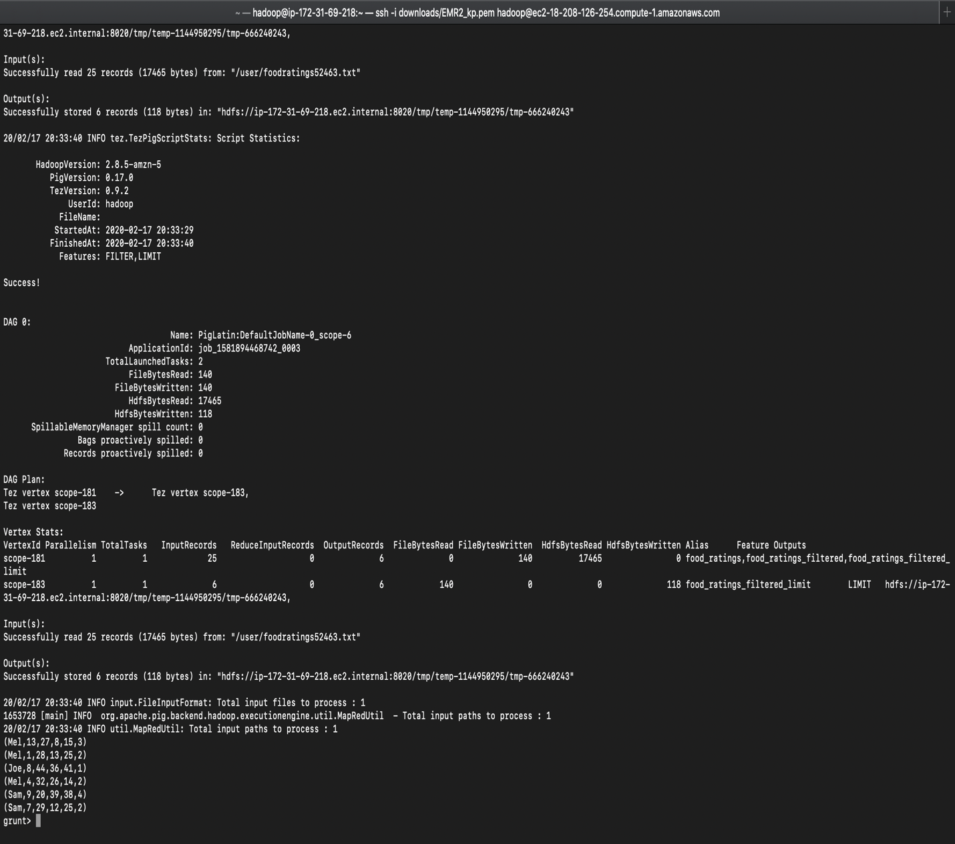

**Exercise 5) 2 points**

**Using the initial (food_ratings) relation, write and execute a sequence of pig latin statements that creates another relation, call it ‘food_ratings_2percent’, holding a random selection of 2% of the records in the initial relation.**

**Write 10 of the records out to the console.**

**Submit the pig latin statements and the records printed out to the console**

**Command:**

COMMAND:

food_ratings_2percent = SAMPLE food_ratings 0.02;

food_ratings_2percent_limit = LIMIT food_ratings_2percent 10;

dump food_ratings_2percent;



**Exercise 6) 2 points**

**Write and execute a sequence of pig latin statements that loads the foodplaces file as a relation. Call the relation ‘food_places’. The load command should associate a schema with this relation where the first attribute is referred to as ‘placeid’ and is of type int and the second attribute is referred to as ‘placename’ and is of type chararray.**

**Execute the describe command on this relation.**

**Now perform a join between the initial place_ratings relation and the food_places relation on the placeid attributes to create a new relation called ‘food_ratings_w_place_names’. This new relation should have all the attributes (columns) of both relations. The new relation will allow us to work with place ratings and place names together.**

**Write 6 records of this relation out to the console.**

**Commands:**

food_places = LOAD '/user/foodplaces52463.txt' USING PigStorage(‘,’) AS (placeid:int,placename:Chararray);

food_ratings_w_place_names = JOIN food_ratings BY placeid, food_places BY placeid;

food_ratings_w_place_names_limit = LIMIT food_ratings_w_place_names 6;

dump food_ratings_w_place_names_limit;

**Exercise: 7**

**1. Limit (A)**

**2. Distinct (C)**

**3. (f1: STRING, f2: INT, f3: INT, f4: INT) ( B)**

**4. relB = FOREACH relA GENERATE $0, f3; ( B)**

**5. DataFlow (B)**

**6. relB = FILTER relA by $0 < 20**